November 2026
Sun | Mon | Tue | Wed | Thu | Fri | Sat
COFFEE HOUSE OPEN
Sunday – Saturday: 9:00 PM – 7:00 AM
201 N. 24th St., Bismarck, ND 58501
701-223-6315
1 | 2 | 3  Food Pantry  9:30 am – 11:30 am  Ice Cream Social & Open/HRCC Reentry Hours  1:30 pm – 4:00 pm | 4 | 5  Food Pantry  5:00 pm – 7:00 pm  Re-Entry Meal and  Support  6:30 pm – 8:00 pm  @ Trinity Lutheran Church | 6  Positive Table Talk  and Open Hours  7:15 am – 9:00 am | 7
8 | 9 | 10  Vaccinations  9:30 am – 11:30 am  Food Pantry  9:30 am – 11:30 am  FREE HAIRCUTS  2:00 pm – 4:00 pm  Ice Cream Social & Open/HRCC Reentry Hours  1:30 pm – 4:00 pm  Acupuncture  2:00 pm – 4:00 pm | 11 | 12  Food Pantry  5:00 pm – 7:00 pm | 13  Positive Table Talk  and Open Hours  7:15 am – 9:00 am | 14
15 | 16 | 17  Food Pantry  9:30 am – 11:30 am  Ice Cream Social & Open/HRCC Reentry Hours  1:30 pm – 4:00 pm | 18 | 19  Food Pantry  5:00 pm – 7:00 pm  Humane Society Distribution  5:00 pm – 7:00 pm | 20  Positive Table Talk  and Open Hours  7:15 am – 9:00 am | 21
22 | 23 | 24  Food Pantry  9:30 am – 11:30 am  Ice Cream Social & Open/HRCC Reentry Hours  1:30 pm – 4:00 pm  Acupuncture  2:00 pm – 4:00 pm | 25 | 26  Thanksgiving Day – Offices Closed   | 27  Positive Table Talk  and Open Hours  7:15 am – 9: 00 am | 28
29 | 30
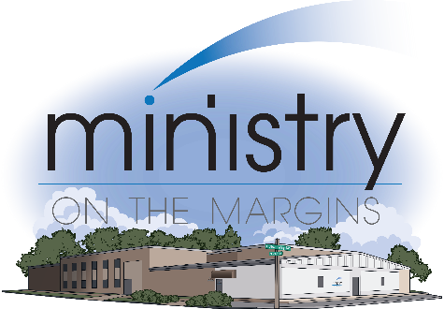
Notes: Open Hours is a time for connection to care for anyone seeking information or services.
Re-Entry Supper and Support will be held at Trinity Lutheran Church:
502 N 4th St.
Bismarck, ND 58501

